**Title:** Creating Power BI dashboard using supermarket sales dataset.

## Dataset Used:

Dataset: [https://drive.google.com/file/d/1M3vt4tGFXZyXIGkuSr-](https://drive.google.com/file/d/1M3vt4tGFXZyXIGkuSr-hEMrQaMzPNDIV/view?usp=sharing) [hEMrQaMzPNDIV/view?usp=sharing](https://drive.google.com/file/d/1M3vt4tGFXZyXIGkuSr-hEMrQaMzPNDIV/view?usp=sharing)

The dataset is "Supermarket Sales," which includes detailed

transaction records of a supermarket's sales, customer information, shipping modes, and product details. It contains 21 columns and 9,994 rows.

## Column Descriptions:

1. **Row ID:** Unique identifier for each row in the dataset.
2. **Order ID:** Unique identifier for each order.
3. **Order Date:** Date when the order was placed.
4. **Ship Date:** Date when the order was shipped.
5. **Ship Mode:** Shipping method (e.g., Standard Class, Second Class).
6. **Customer ID:** Unique identifier for each customer.
7. **Customer Name:** Name of the customer placing the order.
8. **Segment:** Customer segment (e.g., Consumer, Corporate, Home Office).
9. **Country/Region:** Country or region of the customer.
10. **City:** City where the order was placed.
11. **State:** State where the order was placed.
12. **Postal Code:** Postal code of the shipping address (some missing values).
13. **Region:** Geographic region of the order (e.g., SouthWest, East).
14. **Product ID:** Unique identifier for each product.
15. **Category:** Product category (e.g., Furniture, Office Supplies, Technology).
16. **Sub-Category:** Sub-category of the product (e.g., Bookcases, Chairs).
17. **Product Name:** Name of the product.
18. **Sales:** Revenue generated from the product sale.
19. **Quantity:** Number of units sold.
20. **Discount:** Discount percentage applied to the product.
21. **Profit:** Profit margin on the product sale.

This dataset provides comprehensive information for analyzing sales performance and customer behavior, serving as a foundation for creating a meaningful Power BI dashboard.

*'i I* V «

**Row ID Order ID OrderDate Ship Date ShipMode CustomerID Customer Name Segment Country/Region City State** [ **r::l**

II

.**n**..**,**.

*43* CA-2020-101343 *17 July 2020 22 July 2020* StandardClass RA-19885 RubenAusman Corporate UnitedStates LosAngeles Calif,"" **n,**

*514* CA-2021-163405 *21 December2021 25 December2021* StandardClass BN-11515 BradleyNguyen Consumer UnitedStates LosAngeles Calif,I

*515* CA-2021-163405 *21 December 2021 25 December 2021* S andardClass BN-11515 BradleyNguyen Consumer UnitedStates LosAngeles Calif,

*1606* US-2020-115819 *19 April2020 24 April 2020* SecondClass JO-15280 Jas O'Carroll Consumer UnitedStates LosAngeles Calif,

DD

|  |  |  |  |  |  |  |  |
| --- | --- | --- | --- | --- | --- | --- | --- |
| *1607* | US-2020-115819 19 *April2020* | *24 April 2020* SecondClass | JO-15280 | Jas O'Carroll | Consumer | UnitedStates | LosAngeles Calif, |
| *1609* | US-2020-115819 *19 April2020* | *24 April 2020* SecondClass | JO-15280 | Jas O'Carroll | Consumer | UnitedStates | LosAngeles Calif, |
| *1807* | US-2020-116729 *25 December2020* | *28 December 2020* First Class | GK-14620 | GraceKelly | Corporate | UnitedStates | LosAngeles Calif, |
| *2060* | CA-2018-106439 *31 October 2018* | *04 November2018* StandardClass | GG-14650 | GregGuthrie | Corporate | UnitedStates | LosAngeles Calif, |
| *2061* | CA-2018-106439 *31October2018* | *04 November2018* StandardClass | GG-14650 | GregGuthrie | Corporate | UnitedStates | LosAngeles Calif, |
| *2063* | CA-2018-106439 *31 October 2018* | *04 November2018* StandardClass | GG-14650 | GregGuthrie | Corporate | UnitedStates | LosAngeles Calif, |
| *2065* | CA-2018-106439 *31 October 2018* | *04 November2018* StandardClass | GG-14650 | GregGuthrie | Corporate | UnitedStates | LosAngeles Calif, |
| *2068* | CA-2018-106439 *31 October 2018* | *04 November2018* S andardClass | GG-14650 | GregGuthrie | Corporate | UnitedStates | LosAngeles Calif, |
| *2191* | CA-2020-118913 *25 June 2020* | *29 June2020* S andardClass | AS-10240 | AlanShonely | Consumer | UnitedStates | LosAngeles Calif, |
| *2492* | CA-2018-113579 *13 December2018* | *15 December 2018* SecondClass | KD-16345 | KatherineDucich | Consumer | UnitedStates | LosAngeles Calif, |
| *2944* | CA-2021-126242 *19 November2021* | *24 November 2021* StandardClass | MC-18100 | MickCrebagga | Consumer | UnitedStates | LosAngeles Calif, |

lOA (A_?01Q_11MAO rn*n,il )nJQ n* l1nrrf Jtlrn Ct-:in,hirrl rl'Jr<' 11_1,91, lnhn I ac (1,nr11mcr I lnitan Ct-:itac Inc hnr,clcr r'llifi**T**

**Sum of Sales tly Order Date**

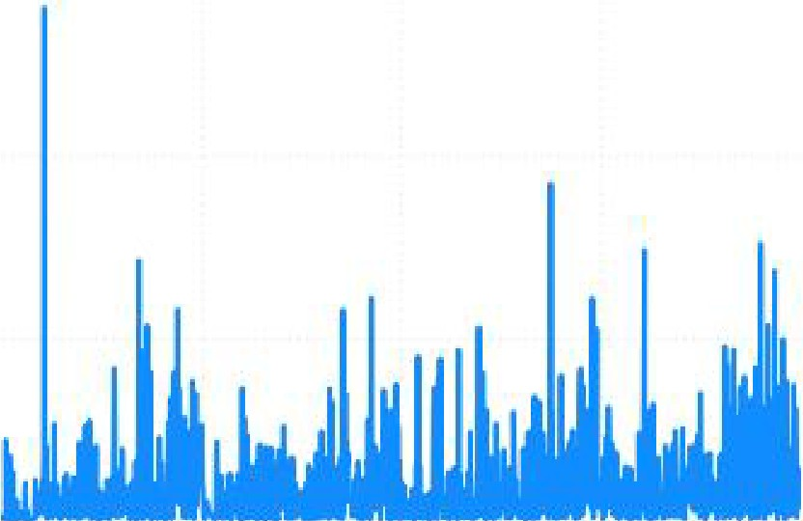JOK

., 20K

_!!

0

E

ill

# 2.30M

Sum of Sall!

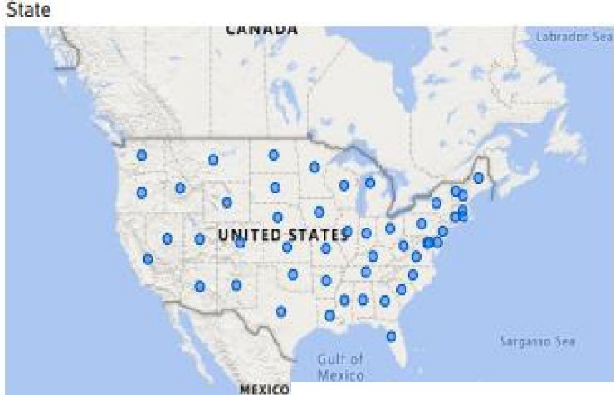

clih

IOK

DK

2D19 20211 2021

Order Da!,e

# 286.4...

Sum of Profit

I,

HAIT"I IN

l S:1

---

o.;,,,-

e

tegory

Sum el Sales by Sub-Category

Sum of Sales by Region

5um ofSales by Ca

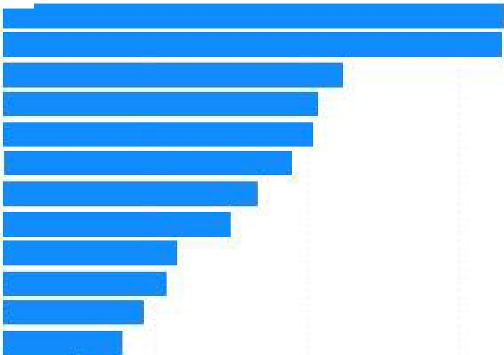P'hon

Chtiirs

..

SLo-r'ag!!!

e- Binders

g, M i

Acaucrie

,Q Copiers

.;: lilookca

Appli11nCl!s

Fumistwig

Pop,r

Supplie•-

[LCII• (111, *011,*

Sum of Sal.e.5

DJU

501-24K

(2U_J

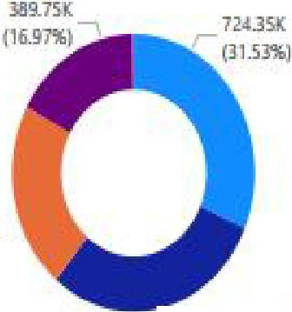

'- oll!.71iK f,!.g.lM\)

R.,ghm

* West

**eE.m**

* eencral

**esooth**

esauthWest

Ca cry

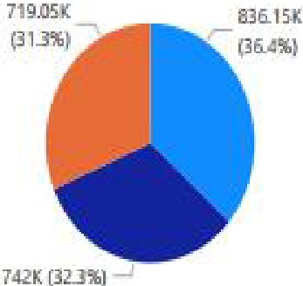Hedinology

* + Furniture

**aom e**Suwl.